
Lilly’s 4Q 2025 Earnings Call

Company: Lilly  Drug: Jaypirca (pirtobrutinib: ncBTKi) | Date: Feb 04, 2026  Source(s): webcast, press release, presentation, financial workbook
What happened:
- Lilly expects data readout and regulatory filing for the Jaypirca combination in R/R CLL BRUIN-CLL-322 (pirtobrutinib + Ven + R; 2L+ CLL) In 2026.
- Lilly confirmed US and EU regulatory submissions of Jaypirca in 1L CLL (BRUIN-CLL-313 (pirtobrutinib vs BR; 1L CLL) and BRUIN-CLL-314 (pirtobrutinib vs IMB; 1L+ CLL)).
  - A regulatory decision was anticipated in 2026, though it was not specified whether this timeline applies to one region or both.

Impact (CI PoV): HIGH
- The potential impact of Jaypirca monotherapy in 1L CLL on Ven + Gazyva (obinutuzumab; aCD20) is expected to be minimal compared with continuous cBTKi regimens, given the strong appeal of a fixed-duration, treatment-free interval, along with established HCP familiarity and market presence of the Ven + Gazyva.
  - In R/R CLL, the BRUIN-CLL-322 combination (Jaypirca + venetoclax + rituximab) is likely to expand venetoclax utilization and could represent the first fixed-duration regimen incorporating Jaypirca, aligning with Lilly’s positioning in post-cBTKi settings and the broader shift toward FDT.

Why it matters (CI Insights in blue italics):
- Lilly plans to pursue approval for the first Jaypirca combination (pirtobrutinib + Ven + R; 2L+ CLL) in the R/R setting, supporting a fixed-duration regimen.
  - Given a trial PCD in Oct 2026, data and filing could occur by YE 2026, potentially at ASH 2026, with approval expected in 2Q 2027 under priority review (6 months) or in 4Q 2027 (10 months) under standard review.
  - Jaypirca is currently approved only as a continuous monotherapy in the R/R setting; approval of a fixed-duration regimen could allow Jaypirca to address a broader patient segment, including those preferring finite treatment duration.
- Lilly filed in the US and EU for Jaypirca in 1L CLL, with approval anticipated in 2026.
  - Assuming simultaneous US and EU filings in Dec 2025 (with the EU filing having occurred in Dec 2025) following the ASH presentations, approval may be anticipated in 2Q 2026 under priority review (6 months) or 4Q 2026 under standard review (10 months).
  - Positive BRUIN CLL-313/314 data and Jaypirca’s favorable safety profile may encourage earlier switching from cBTKis in cases of early progression or suboptimal response; however, some HCPs may remain cautions, reserving Jayrpica for post-cBTKi use due to resistance concerns and limited long-term pre-cBTKi data.

Tell me more:

Financial Highlights
- Lilly reported 4Q 2025 revenue of $19.3 Bn (+43% YoY), primarily driven by its obesity franchise; FY2025 revenue were $65.2 Bn (+45% YoY).
- Jaypirca Total sales were $148M (+30% YoY) in 4Q 2025 and $506M (+50% YoY) in FY2025.
  - Jaypirca US sales were $113M (+31% YoY) in 4Q 2025 and $410M (+47% YoY) in FY2025, and ex-US sales were $34M (+25% YoY) in 4Q 2025 and $95M (+67% YoY) in FY2025.

USD | Overall
4Q 2025 | Global  $19.3 B  (43%) YoY  (9.6%) QoQ | US  $12.9 B  (43%) YoY  (14%) QoQ
ex-US
$6.4 M
(43%) YoY
(1.8%) QoQ
4Q 2024 | Global  $13.5 B | US  $9.0 B
ex-US
$4.5 B
3Q 2025 | Global  $17.6 B | US  $11.3 B
ex-US
$6.3 B

USD | Jaypirca Sales
4Q 2025 | Global  $148 M  (30%) YoY  (3.5%) QoQ | US  $113 M  (31%) YoY  (-2.6%) QoQ
ex-US
$34 M
(25%) YoY
(25.9%) QoQ
4Q 2024 | Global  $113.6 M | US  $86.2 M
ex-US
$27.4 M
3Q 2025 | Global  $142.9 M | US  $115.8 M
ex-US
$27.2 M

CLL Portfolio
- In the presentation materials, Lilly reiterated the 1L CLL results from BRUIN-CLL-313 and BRUIN-CLL-314, previously presented at ASH 2025, highlighting an 80% (vs BR) and 76% (vs IMB) reduction in risk of progression or death, respectively.
- The company reiterated US approval of Jaypirca in post-cBTKi 2L+ CLL in Dec 2025, based on the Phase 3 BRUIN-CLL-321 trial.

Q&A Highlights:
- No mention of Jaypirca was made during Q&A.

Relevant Slides:

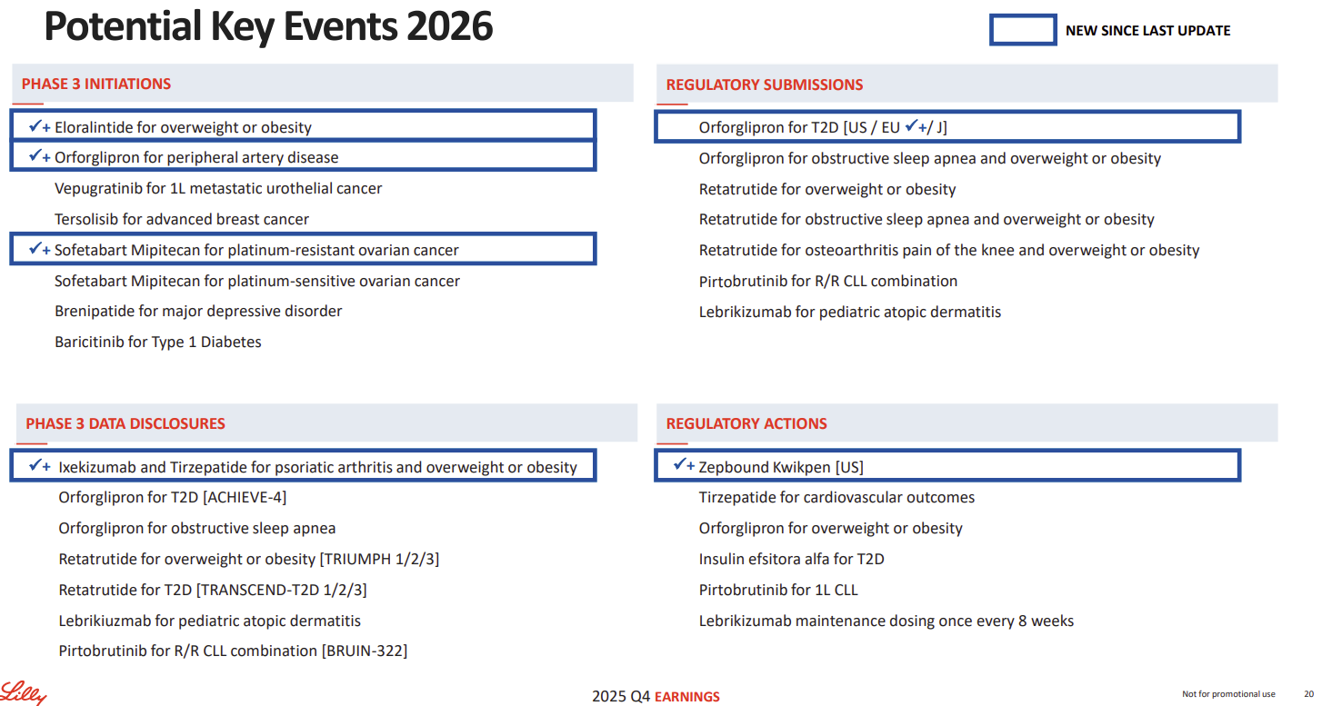

For questions, please reach out to:
International / Affiliates: Harjit Bajwa
US: Richa Sharma
Corporate Strategy, R&D and PCS: Claudia Lanauze Torres

Invite your colleagues to CI Edge | Manage Email Preferences | Unsubscribe

This document contains competitive intelligence collected via APEX/IMABI approved methods or vendors. We collect competitive intelligence consistent with industry standards and AbbVie policy. Not for commercial field distribution. Please reach out to AbbVie Legal or OEC with any questions

